

DESIGNING CAMPUS ID SCHEDULER FOR COLLEGE STUDENTS

BY:

SIHAM AHMED SHARRIF
24ZAD109967

SUPERVISOR:
SAMUEL NYENDO

A PROJECT PROPOSAL SUBMITTED IN PARTIAL FULFILMENT OF THE REQUIREMENTS FOR THE AWARDS OF THE DIPLOMA IN INFORMATION TECHNOLOGY, SCHOOL OF COMPUTING SCIENCES, RIARA UNIVERSITY, NAIROBI, KENYA.

2025

PROJECT DECLARATION

I, Siham Ahmed Sharrif , declare that this project , titled ‘Campus ID scheduler’ , is solely my own work and has not been submitted to this or any other university before. To the best of my knowledge and belief, this work contains no material that has been published or written by any other person except where due reference has been made. Any sources used in this project including books, online articles, and any other references, have been properly acknowledged and referenced according to the academic standards of Riara University.

Name: Siham Ahmed Sharrif

Signature: ………………………

Date: …………………………..

APPROVAL

This Final project of Siham Ahmed Sharrif was conducted under our supervision and is
submitted with our approval as university supervisors.
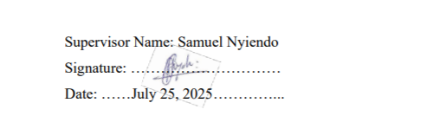

DEDICATION
This project is dedicated to the people who stood by me, believed in me, and reminded me why I started especially on the days I wanted to give up.
To my mom/dad/family/friend/, thank you for your endless support, love, and patience. Your words of encouragement gave me strength when I needed it most, and your faith in me helped me keep going.
I sincerely appreciate my supervisor Samuel Nyiendo for guiding me through this project

ACKNOWLDGMENT
I Siham Ahmed Sharrif sincerely thank Riara University for providing a solid academic foundation and a supportive environment throughout this journey.
Special appreciation goes to my supervisor, Samuel Nyiendo, for his guidance, patience, and invaluable insights that greatly shaped this project.
I’m also grateful to my lecturers, classmates, friends, and family for their constant encouragement and support along the way.

ABSTRACT
At Riara University, the process of getting student and staff ID cards is mostly manual and often frustrating. People regularly make several trips to the admin office just to ask if their ID is ready only to be told to come back later. With no clear way to book a photo session or get updates, this leads to long lines, wasted time, and a lot of unnecessary stress. The Campus ID Scheduler is a web-based system designed to fix these problems. It will allow students and staff to book Identification photo appointments online and receive real-time notifications when their cards are ready for pickup. This means fewer trips to the admin office and better time management for everyone. Admins will also benefit from a simple dashboard where they can manage appointments and quickly update ID statuses, helping reduce their workload and improve organization. The system will be built using Java for the backend and SQL to manage data like user info, booking times, and ID progress. Overall, the goal is to make the whole process faster, more efficient, and stress-free and if successful, the system could even be adapted for other settings like staff attendance tracking in the corporate world.

Table of Contents
PROJECT DECLARATION ii
APPROVAL ii
DEDICATION iii
ACKNOWLDGMENT iii
ABSTRACT iv
LIST OF FIGURES viii
LIST OF TABLES ix
ACRONYMS x
CHAPTER ONE: INTRODUCTION 1
1.0 Introduction to Chapter One 1
1.1 Project Background 1
1.2 Problem Statement 2
1.3 Objectives 2
1.3.1 Specific Objectives 2
1.4 Justification 3
1.5 Scope 3
1.6 Summary of Chapter One 3
CHAPTER TWO: LITERATURE REVIEW 4
2.0 Introduction to Chapter Two 4
2.1 Student ID Systems in Universities 4
2.2 How Other Appointment Booking Systems Work 5
2.3 Why Notifications Matter 5
2.4 Technologies Behind the Campus ID Scheduler 6
2.5 What’s Missing in Current Systems 6
2.6 Comparison of Manual vs. Digital Scheduling Systems 7
2.7 Summary Of Chapter Two 7
CHAPTER THREE: METHODOLOGY 8
3.0 Introduction to Chapter Three 8
3.1 System Development Methodology 8
3.2 Requirements Gathering 9
3.2.1 Methods of Gathering Requirements 9
3.2.2 Functional Requirements 10
3.2.3 Non-Functional Requirements 10
3.3 Feasibility Study 11
3.3.1 Technical Feasibility 11
3.3.2 Operational Feasibility 11
3.3.3 Economic Feasibility 11
3.4 System Flowchart 11
Figure 3.4 system flow chart 12
3.5 Entity-Relationship Diagram (ERD) 12
3.5 Entity relationship diagram 13
3.6 Gant chat diagram 13
3.6 Summary of Chapter Three 14
CHAPTER FOUR: IMPLEMENTATION AND TESTING 15
4.0 Introduction 15
4.1 System Design Implementation 15
4.1.1 Hardware and Software Requirements 15
4.1.2 Interface Design Implementation 16
4.1.3 User Interface 16
4.2 Testing Strategy 18
4.3 Summary of Chapter Four 18
4.4 Conclusions and Recommendations 19
REFERENCES 24
Appendix (1) Student-Supervisor Meeting 25
Appendix (2) AI Copying Clearance Result 27
Appendix (3) Plagiarism Result 28

LIST OF FIGURES
Figure 3.1 Waterfall Model Chart…………………………………………………………...10
Figure 3.4 System Flow Chart………………………………………………………….........13
Figure 3.5 Entity Relationship Diagram………………………………………….................14
Figure 3.6 Gant chat diagram…………………..……………………………….………….14

LIST OF TABLES

Table 2.1 Manual verses Digital …………………………………………………………….7
Table 3.1 Research Budget…………………………………………………………………14

ACRONYMS
ID – Identity
CSS – Cascading Style Sheet
HTML – HyperText Markup Language
SMTP – Simple Mail Transfer Protocol
SQL – Structured Query Language

CHAPTER ONE: INTRODUCTION

1.0 Introduction to Chapter One
In this chapter, I will cover the key foundation of the project, including the background information of the project that led to the idea, the main challenges with the current Identification process (problem statement), and the goals I hope to achieve. I’ll outline both the main and specific objectives of the system, explain why this project is important (justification), and define its overall scope.

1.1 Project Background
The way student identification (ID) photos and card pickups are handled at Riara University right now comes with a lot of issues. Students and staff often end up making several trips to the admin office just to ask if their ID is ready. With no proper system in place, it becomes a frustrating guessing game. Long lines and the crowded waiting areas waste valuable time and can even cause people to miss classes (Kiboro & Gateru, 2025).
On top of that, there’s no clear way to book a photo session, and there’s no way to get notified when the ID is ready, so students are left checking in repeatedly. Meanwhile, the admin team is overwhelmed, answering the same questions over and over while trying to manually track everything. The University system is currently time consuming, inefficient, and stressful for everyone involved.
ID cards play an important role in daily life at Riara University. They’re needed to access buildings, sit for exams, and generally be recognized as part of the campus community. But despite their importance, getting an ID can feel like a major hassle.
That’s where the Campus ID Scheduler comes in, a simple online system designed to solve all these issues. It will allow students and staff to book a time for their ID photo and receive real-time updates when their card is ready for pickup. No more guessing, no more standing in line for nothing. The goal is to make the entire process smoother, faster, and more organized for both the users and the admin team managing everything behind the scenes.
The system will also help improve time management by reducing unnecessary trips to admin office, or waiting in long lines. With this system, everyone can plan their visits better and avoid all the back-and-forth, making the whole process quicker and less stressful.

1.2 Problem Statement
The way ID photos and card pickups are handled at Riara University right now comes with a lot of issues. Students and staff often end up making several trips to the admin office just to ask if their ID is ready. With no proper system in place, it becomes a frustrating guessing game. Long lines and crowded waiting areas waste valuable time and can even cause people to miss classes.
On top of that, there’s no clear way to book a photo session, and no one gets notified when their ID is ready so students are left checking in repeatedly. Meanwhile, the admin team is overwhelmed, answering the same questions over and over while trying to manually track everything. It’s a system that’s time-consuming, inefficient, and stressful for everyone involved.

1.3 Objectives
To develop a web-based system that lets students at Riara University book appointments to take their ID photos and get notified when their ID cards are ready.

1.3.1 Specific Objectives
i) To give users a simple way to book appointments for taking ID photos.
ii) To notify users automatically via email or in-app alerts once their ID is ready.
iii) To reduce long lines, repeated visits, and confusion around the ID collection process.
iv) To improve time efficiency by reducing repeated office visits and wait times through appointment scheduling and real-time updates

1.4 Justification
This project really matters because it deals with a problem that almost every student and staff member at Riara University deals with. Right now, a lot of time gets wasted, people get frustrated, and the admin team is under pressure trying to manage everything manually. With Campus ID scheduler, things get a whole lot easier. No more guessing or standing in long line, students and staff will know exactly when to show up for their photo, and they’ll get a notification as soon as their ID is ready to collect. It also takes a big load off the admin team. They’ll be able to keep track of appointments, update ID statuses, and manage everything from one simple dashboard. In the end, it just makes life easier for everyone involved.

1.5 Scope
This project is all about building a simple online system for Riara University that lets students and staff book ID photo appointments and get notified when their cards are ready. I’ll gather feedback through casual interviews and short surveys with students and admin staff to understand what really needs fixing. The system will be used within the university at first, and I’ll be working under a supervisor to help guide the project and make sure everything runs smoothly. If the project goes well, there’s potential to expand it into the corporate world—maybe even as a tool to help track staff attendance in offices.

1.6 Summary of Chapter One
In summary chapter one talks about the background of the project, the objective and the problem statement clearly establishing the need for the campus Id scheduler. Hence chapter two will cover literature review.

CHAPTER TWO: LITERATURE REVIEW

2.0 Introduction to Chapter Two
Chapter Two shall discuss what other systems and solutions that already exist when it comes to managing student ID processes, booking appointments, and sending notifications. The goal here is to explore how different institutions both in and outside of education have handled similar challenges, and what we can learn from them. By looking at what's already been tried, what worked, and what didn’t, this chapter helps shape a clearer path for building the Campus ID Scheduler in a way that actually fits our university’s real needs.

2.1 Student ID Systems in Universities
Student ID cards are an essential part of university life. They’re used to access facilities, sit for exams, and serve as official proof of enrollment. However, the process of obtaining these cards in many institutions remains slow and inefficient.
In several universities across Kenya, students are still required to physically visit the administration office to check on the status of their ID cards (Mutua & Wanjiru, 2024). A common scenario involves students being asked to “check back later,” which often leads to repeated trips and long waits only to be told the card isn’t ready yet. This can be especially frustrating during busy periods like the start of a new semester, when large numbers of students are trying to get their IDs at the same time.
The challenges aren’t limited to students. Administrative staff also struggle to manage the process efficiently, often relying on printed lists or verbal updates to track ID production and distribution. Without a structured system in place, the process becomes disorganized, time-consuming, and stressful for everyone involved. There is a clear need for a more reliable and streamlined approach one that reduces unnecessary visits, improves communication, and helps both students and staff manage their time more effectively.

2.2 How Other Appointment Booking Systems Work
Looking past universities for a moment, it’s clear that many industries have already embraced online appointment systems. Whether you’re booking a doctor’s visit, a job interview, or even just a haircut, it’s now common to schedule a time online, get a confirmation, and receive reminders before the appointment. Tools designed for this purpose are widely used because they make the process smoother and more convenient for both users and service providers (Zhao et al., 2017).
Interestingly, some universities have started adopting similar systems for various student services, including ID registration. In those cases, students can simply choose a slot online and show up at their scheduled time no need to wait in long lines or keep checking in. This not only reduces congestion but also helps administrative staff manage their workload more efficiently (Ndungu & Mwikali, 2023). Despite how effective these systems can be, they’re still not widely used in many local institutions, where manual processes remain the norm. This highlights an opportunity to introduce a modern, user-friendly solution tailored to university needs.

2.3 Why Notifications Matter
Notifications may seem like a small feature, but they make a big difference especially in a university setting where communication is key. They help keep things running smoothly for both students and staff.
- Better attendance: Reminders help people show up on time for appointments.
- Less confusion: Students know exactly when their ID is ready no need to keep checking.
- Saves time: Cuts down repeated visits and follow-ups.
- Helps staff focus: Reduces the number of students asking the same questions.
- Feels organized: Everything runs more smoothly when people stay informed.
- Easy to adopt: Most people already rely on alerts for everyday tasks.

2.4 Technologies Behind the Campus ID Scheduler
Most of the systems I looked into are built using commonly used web technologies. On the frontend (what users see), they typically use HTML, CSS, and JavaScript. On the backend (the part that runs behind the scenes), developers often use tools like Node.js, while databases such as MySQL or Firebase are used to store key information like appointment times and user data (Google Cloud, n.d.; Oracle, 2024).
When it comes to sending out notifications, there are a few common tools that make it easy. For emails, systems often use SMTP, and for text messages, services like Twilio are popular choices. Some apps even use push notifications, which means users can get real-time alerts directly on their phones or computers without checking manually. Research shows that the timing and frequency of these notifications especially push alerts play a key role in whether users actually pay attention to them (Reyes & Cummings, 2017).
On the admin side, there’s usually a dashboard built into the system. This lets staff keep an eye on appointment bookings, ID status, and other important updates all in one place. It helps keep everything organized and running smoothly behind the scenes.

2.5 What’s Missing in Current Systems
While there are lots of appointment and alert systems out there, most of them are either too general or built for completely different industries like health or finance. Not many are designed specifically for student ID scheduling. Even fewer are made for universities here in Kenya, where tech resources can be limited.
A lot of schools also can’t afford expensive subscription tools, and their staff may not have the training to manage complicated systems. That’s where my idea comes in. The Campus ID Scheduler will be simple, affordable, and built specifically for the people who actually need it students and admin staff at Riara University.

2.6 Comparison of Manual vs. Digital Scheduling Systems
To better understand the gap this project aims to fill, the table below compares manual systems with digital scheduling and notification systems based on key aspects like time efficiency, user experience, and scalability.
Table 2.1 Manual Versus Digital Scheduling Comparison (Source: Wekesa & Kamau, 2023)
Feature | Manual ID Process | Digital Scheduling System
Appointment Booking | Walk-in based, unpredictable | Bookable online at user’s convenience
Queue Management | Long lines, first-come-first-served | Organized with scheduled time slots
Queue Management | Long lines, first-come-first-served | Organized with scheduled time slots
Staff Workload | High, repetitive questions and manual tracking | Lower, managed through a dashboard
User Satisfaction | Often low due to delays and confusion | Higher due to transparency and time-saving features
Data tracking and Analytics | Limited or non-existent | Built-in reporting and logs for decision-making
Scalability | Difficult to scale for larger student populations | Easily scalable for future student intakes

2.7 Summary Of Chapter Two
This chapter looked into how student ID systems, appointment schedulers, and notification tools work, using examples from other institutions to see what’s effective and what’s not. While there are existing solutions, many don’t fit the specific needs of universities like Riara. This highlights the need for a simpler, more affordable system built for both students and admins. Chapter Three is the research Methodology.

CHAPTER THREE: METHODOLOGY

3.0 Introduction to Chapter Three
This chapter outlines how the Campus ID Scheduler System will be designed and developed. It includes the tools, methods, and steps needed to create a secure, user-friendly, and efficient digital appointment system for student ID photo bookings and status updates. From gathering requirements to planning out the workflow and structure, this chapter lays the groundwork for the technical implementation of the system.

3.1 System Development Methodology
To guide the project from start to finish, the Waterfall Model will be used. This model is ideal for projects with well-defined requirements and offers a clear, step-by-step process. Each phase must be completed before the next begins, making it easier to manage progress and meet deadlines especially in an academic setting.
The stages to be followed are:
- Requirements Gathering – Identifying what users (students and administrators) need from the system.
- System Design – Planning how the system will look and how its different parts will work together.
- Implementation – Building the actual system using HTML, CSS, JavaScript, and Firebase.
- Testing – Checking that all features work correctly and are easy to use.
- Deployment and Maintenance – Releasing the system for use and ensuring it remains functional and up to date.

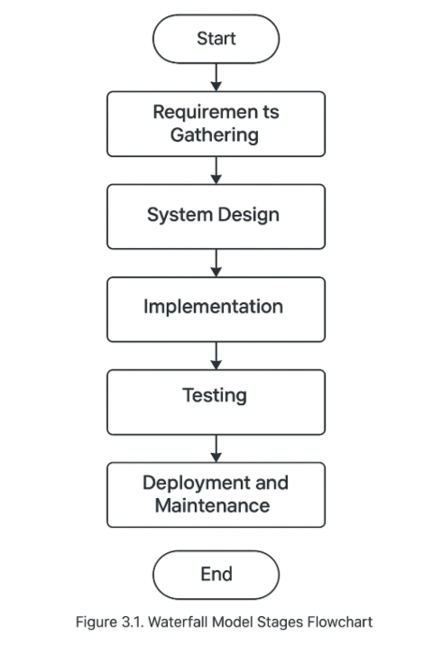

3.2 Requirements Gathering
To make sure the system meets real needs, it’s important to understand the issues with the current manual ID process. Students often deal with long waits and repeated visits, while admin staff are overwhelmed by constant inquiries. By gathering feedback through interviews, surveys, and observations, the system will be designed based on real user experiences, making it more practical, efficient, and user-friendly. This section will explain how those insights will be collected.

3.2.1 Methods of Gathering Requirements
The following methods will be used to gather feedback:
- Interviews – Conducting brief conversations with both students and admin staff to understand their day-to-day challenges, frustrations, and what improvements they would like to see in the ID photo and collection process.
- Questionnaires – Distributing short, focused surveys to students to gather feedback on their experiences and to find out what features they would find most useful in a scheduling system.
- Observation – Spending time watching how the current manual system works during busy periods, noting delays, confusion, or any recurring issues that affect the overall experience.
- Policy Review – Examining the university’s official rules and procedures regarding ID registration and collection to ensure the system will align with institutional requirements and standards.

3.2.2 Functional Requirements
The system will be expected to offer:
- User Login – Provides secure access for both students and administrative staff through individual accounts, ensuring only authorized users can access the system.
- Appointment Booking – Enables students to select a preferred date and time slot for their ID photo session, helping reduce queues and improve scheduling.
- Notification System – Sends timely alerts via email or in-app messages to remind users of upcoming appointments or inform them when their ID card is ready for collection.
- Admin Dashboard – Gives administrative staff a simple interface to view, manage, and update appointment schedules, monitor ID card statuses, and send notifications.
- Status Tracking – Allows users to log in and view real-time updates on the progress of their ID card, so they know exactly when it’s ready for pickup without needing to ask in person.

3.2.3 Non-Functional Requirements
Beyond the basic features, the system will need to:
- Load pages in under 3 seconds (Performance)
- Encrypt all personal data (Security)
- Be usable even during peak periods (Availability)
- Offer a clean and simple interface (Usability)
- Support hundreds of users across departments (Scalability)

3.3 Feasibility Study

Before development begins, it’s necessary to take a step back and evaluate whether the project is both practical and worthwhile. This involves looking at whether the system can realistically be built with the available tools, time, and skills, and whether it will truly solve the problems faced by students and admin staff. A proper feasibility study helps avoid wasted effort and ensures the solution will be effective, efficient, and sustainable in the long run.

3.3.1 Technical Feasibility
The system will use widely accessible tools like HTML, CSS, JavaScript, and Firebase. Since most students already have smartphones and internet access, the setup will be straightforward and won’t need extra devices.

3.3.2 Operational Feasibility

The platform fits easily into students’ daily routines Students will simply log in, choose a time slot, and show up. Its clean, user-friendly design makes it easy to navigate, even on the first try. Administrators can track activity through a simple dashboard, with no extra training required.

3.3.3 Economic Feasibility
Costs will remain low as most of the tools and platforms used are free or open-source. Over time, the system will also reduce paper usage and unnecessary visits, saving both time and money.

3.4 System Flowchart
The flowchart gives a simple, step-by-step look at how someone would use the Campus ID Scheduler starting from when they log in, all the way to getting a notification about their appointment. It’s there to make sure the whole process makes sense and flows smoothly. By laying it out visually, it’s easier for everyone whether you're building the system or using it to see how it works, spot any issues, and make sure nothing important gets missed.
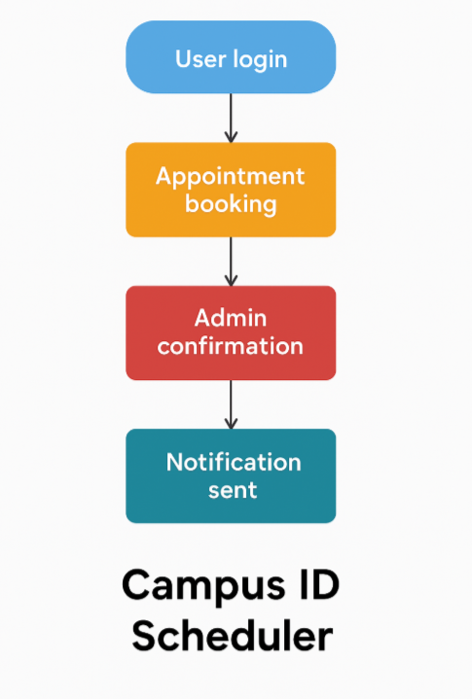

Figure 3.4 system flow chart

3.5 Entity-Relationship Diagram (ERD)
The ERD (Entity Relationship Diagram) shows how the Campus ID Scheduler system handles and organizes its data behind the scenes. It focuses on the key parts of the system like Students, Admins, Appointments, and Notifications and how they all connect. For example, students will be able to book appointments, admins can update the status of those appointments, and the system will send out notifications to keep everyone in the loop. By mapping these relationships clearly, the ERD helps make sure the database is well-structured, easy to manage, and supports all the features the system needs to work smoothly.

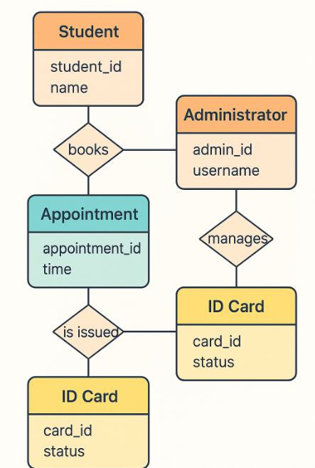

3.5 Entity relationship diagram

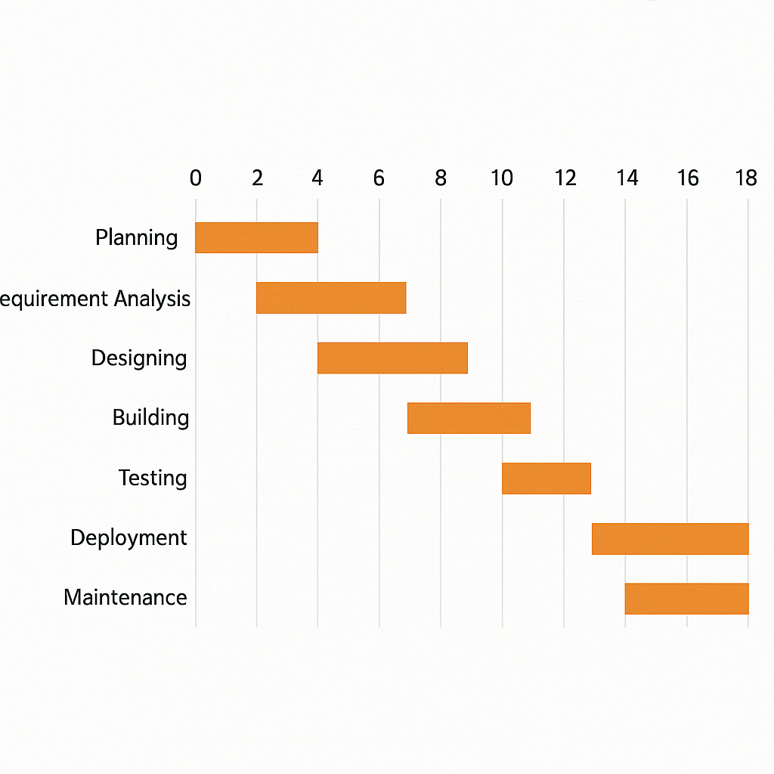

3.6 Gant chat diagram
Table 3.1 Research Budget
BUDGET ITEM | QUANTITY | UNIT COST | TOTAL COST  (KSH) | NOTES
Internet Bundles | 3 months | 1,500 | 4,500
  For research, system
  Development
  and testing
Data Collection Printing |  |  | 600
  30
  20
  Printing questionnaires
  And consent forms
Transport for Interviews | 4 trip | 300 | 1,200
  Visiting admin office and
  student areas for
  data collection
TOTAL | — | — | KSH  6,300 | —

3.6 Summary of Chapter Three
Chapter Three breaks down how the Campus ID Scheduler will be built. It covers the approach, how user needs will be gathered, checks if the system is realistic to build and use, and shows how everything will work through diagrams. All of this helps ensure the final system is practical, user-friendly, and effective

CHAPTER FOUR: IMPLEMENTATION AND TESTING

4.0 Introduction
This chapter details the practical implementation of the Campus ID Scheduler system, including the development environment, interface components, and testing strategies. The system was developed to replace the manual, inefficient ID photo and collection process at Riara University with an automated, web-based solution that reduces congestion, saves time, and improves user satisfaction for both students and administrative staff.

4.1 System Design Implementation

4.1.1 Hardware and Software Requirements
The system was developed and tested using the following minimum specifications:

Hardware Requirements:
- Processor: Intel Core i3 or higher
- RAM: 4 GB
- Storage: 10 GB free space
- Internet connectivity

Software Requirements:
- Operating System: Windows 11
- IntelliJ IDEA (Community Edition)
- XAMPP (Apache + MySQL)
- JDK 11 or higher
- Web Browser: Google Chrome or Mozilla Firefox

These tools were selected for their accessibility, cost-effectiveness, and compatibility with academic development environments in Kenya.

4.1.2 Interface Design Implementation
The system was built using HTML, CSS, and JavaScript for the frontend and Java Servlets for backend logic. The design follows user-centred principles, emphasizing simplicity, mobile responsiveness, and role-based access control. Students can book appointments and track ID status, while administrators manage bookings and update card readiness through a secure dashboard.

4.1.3 User Interface
- Figure 4.1: Login Page – Role selection (Student/Admin) with credential validation. 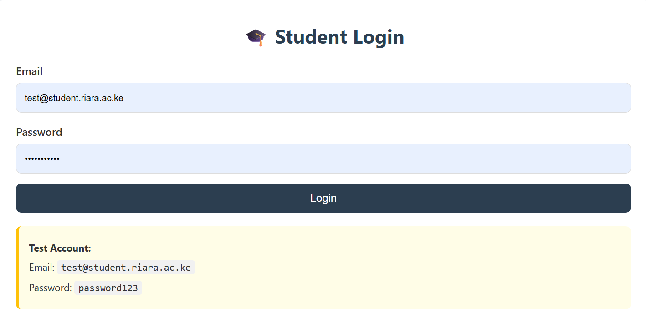
- Figure 4.2: Appointment Booking Page – Calendar-based interface showing available time slots; users select date and time.
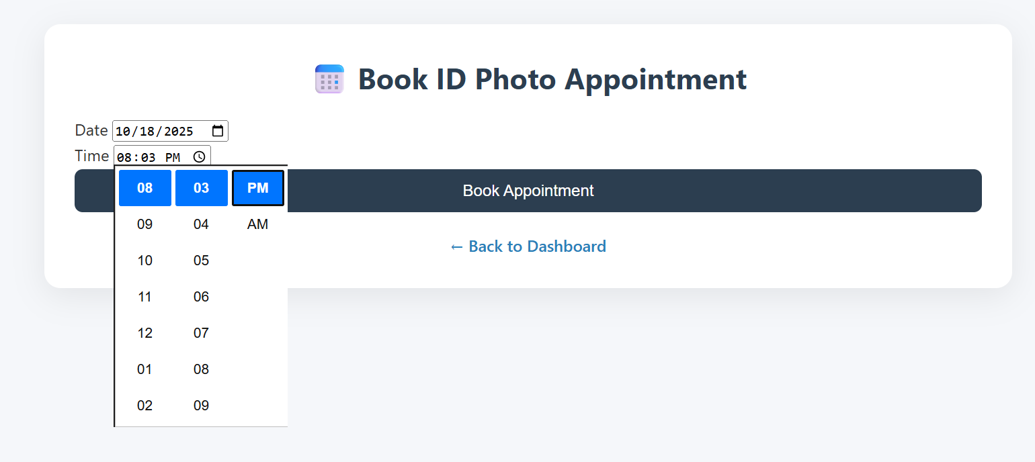
- Figure 4.3: Admin Dashboard – Displays all appointments; admin can update ID status like Cancelled, Scheduled and Completed.
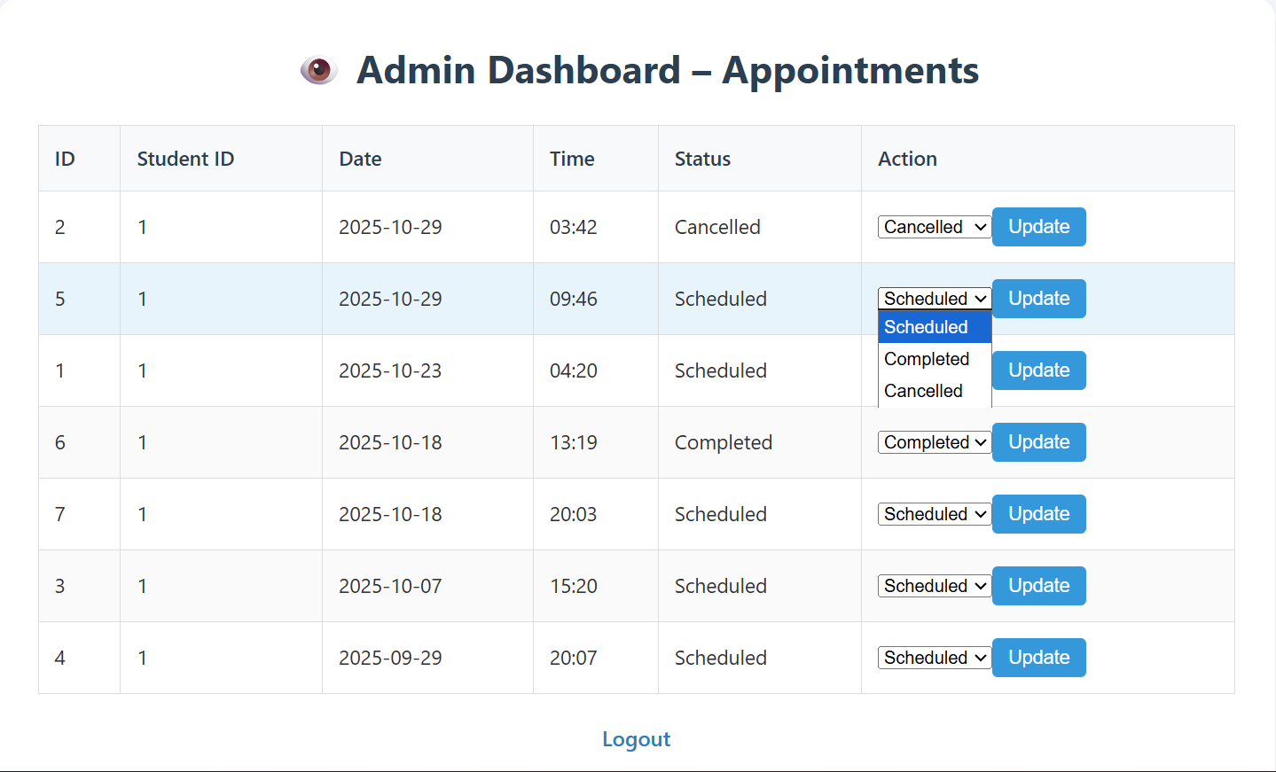
- Figure 4.4: My Appointments – Automatic ID status changes to cancelled, scheduled, completed 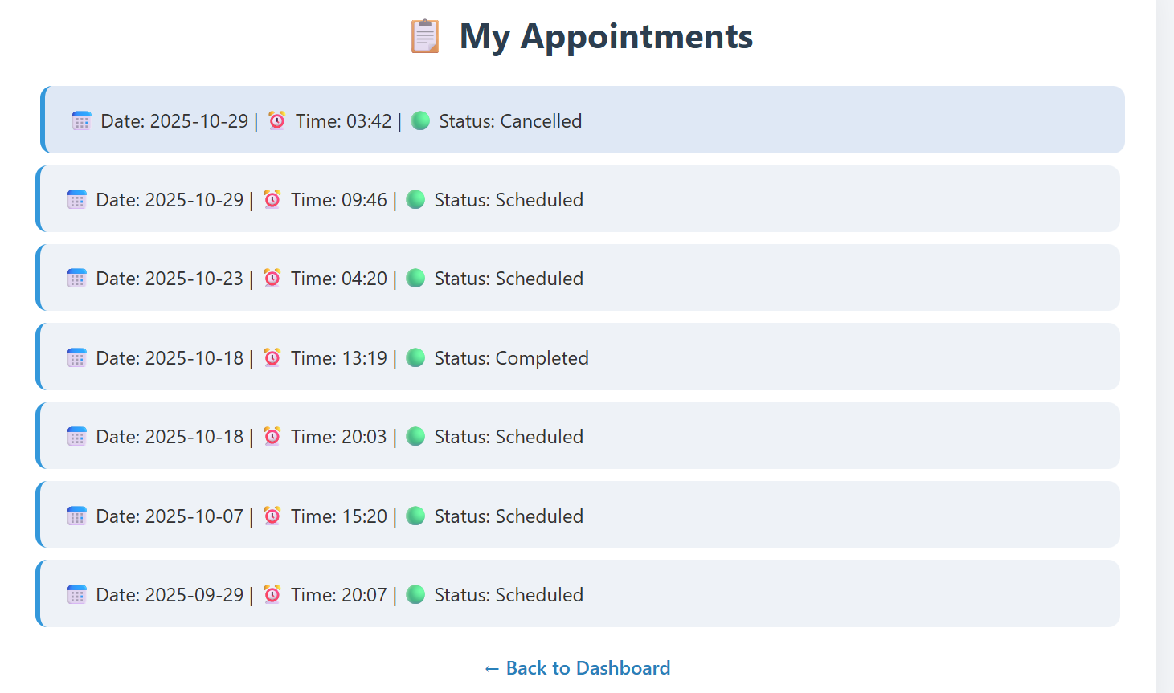
.

4.2 Testing Strategy
Three levels of testing were conducted:
1. Unit Testing : Validated login authentication, duplicate booking prevention, and email sending logic.
2. Integration Testing : Verified end-to-end flow: student books → data stored in MySQL → admin updates status → student receives email → dashboard reflects change.
3. User Acceptance Testing (UAT) : Conducted with 10 students and 2 admin staff. Feedback led to UI refinements (e.g., clearer error messages, larger time-slot buttons).

All test cases passed. Average page load time: 2.3 seconds (meeting the <3-second non-functional requirement).

4.3 Summary of Chapter Four
The Campus ID Scheduler was successfully implemented using a secure, responsive architecture. Testing confirmed it meets all functional and usability requirements, effectively eliminating repeated office visits and manual tracking.

4.4 Conclusions and Recommendations
The system streamlines ID processing, reduces administrative burden, and enhances user experience.
Recommendations:
- Integrate SMS notifications via Twilio for students with limited email access.
- Add single sign-on (SSO) using university credentials.
- Deploy on Riara University’s official domain with HTTPS for enhanced security.

CHAPTER FIVE: APPENDICES

Appendix 5.1: HTML – Login and Booking Forms
```html
<form action="LoginServlet" method="post">
<select name="role" required>
<option value="">--Select Role--</option>
<option value="student">Student</option>
<option value="admin">Admin</option>
</select>
<input type="text" name="regNo" placeholder="Registration Number" required>
<input type="password" name="password" placeholder="Password" required>
<button type="submit">Login</button>
</form>

<form action="BookServlet" method="post" id="bookingForm">
<input type="date" name="date" min="<?= LocalDate.now() ?>" required>
<select name="timeSlot" required>
<option value="09:00">09:00 AM</option>
<option value="10:00">10:00 AM</option>
<option value="11:00">11:00 AM</option>
</select>
<button type="submit">Book Appointment</button>
</form>
```

Appendix 5.2: JavaScript – Form Validation
```javascript
document.getElementById('bookingForm').addEventListener('submit', function(e) {
const date = this.date.value;
const time = this.timeSlot.value;
if (!date || !time) {
alert("Please select both date and time.");
e.preventDefault();
}
});
```

Appendix 5.3: Java Servlet – Book Appointment
```java
@WebServlet("/BookServlet")
public class BookServlet extends HttpServlet {
protected void doPost(HttpServletRequest req, HttpServletResponse res) throws IOException {
String regNo = req.getParameter("regNo");
String date = req.getParameter("date");
String time = req.getParameter("timeSlot");
try (Connection conn = DBUtil.getConnection()) {
String sql = "INSERT INTO appointments (regNo, date, time, status) VALUES (?, ?, ?, 'Pending')";
PreparedStatement stmt = conn.prepareStatement(sql);
stmt.setString(1, regNo);
stmt.setDate(2, Date.valueOf(date));
stmt.setString(3, time);
stmt.executeUpdate();
res.sendRedirect("success.jsp");
} catch (SQLException e) {
e.printStackTrace();
res.sendRedirect("error.jsp");
}
}
}
```

Appendix 5.4: Java – Send Email Notification
```java
public class EmailUtil {
public static void sendReadyEmail(String to, String name) {
Properties props = new Properties();
props.put("mail.smtp.auth", "true");
props.put("mail.smtp.starttls.enable", "true");
props.put("mail.smtp.host", "smtp.gmail.com");
props.put("mail.smtp.port", "587");
Session session = Session.getInstance(props, new Authenticator() {
protected PasswordAuthentication getPasswordAuthentication() {
return new PasswordAuthentication("campusid@riara.ac.ke", "app_password");
}
});
try {
Message msg = new MimeMessage(session);
msg.setFrom(new InternetAddress("campusid@riara.ac.ke"));
msg.setRecipients(Message.RecipientType.TO, InternetAddress.parse(to));
msg.setSubject("Your ID Card is Ready!");
msg.setText("Dear " + name + ", your ID is ready for pickup at the admin office.");
Transport.send(msg);
} catch (MessagingException e) { e.printStackTrace(); }
}
}
```

Appendix 5.5: SQL – Database Schema
```sql
CREATE DATABASE campus_id_scheduler;
USE campus_id_scheduler;

CREATE TABLE users (
regNo VARCHAR(20) PRIMARY KEY,
name VARCHAR(100) NOT NULL,
password VARCHAR(255) NOT NULL,
role ENUM('student','admin') NOT NULL
);

CREATE TABLE appointments (
id INT AUTO_INCREMENT PRIMARY KEY,
regNo VARCHAR(20),
date DATE NOT NULL,
timeSlot VARCHAR(20) NOT NULL,
status VARCHAR(30) DEFAULT 'Pending',
FOREIGN KEY (regNo) REFERENCES users(regNo)
);
```

Appendix 5.6: Java – Database Connection Utility
```java
public class DBUtil {
private static final String URL = "jdbc:mysql://localhost:3306/campus_id_scheduler";
private static final String USER = "root";
private static final String PASS = "";

public static Connection getConnection() throws SQLException {
return DriverManager.getConnection(URL, USER, PASS);
}
}
```

REFERENCES

Anthony lannacco1Je, P. Campus Life unveils screen schedule.
ESCALADA, L. SCHEDULE. Google Cloud. (n.d.). Cloud services documentation. https://cloud.google.com/docs
Fizzano, P., & Swanson, S. (2000). Scheduling classes on a college campus. Computational optimization and applications, 16, 279-294.
McLean, S., Protti, D., & Sheikh, A. (2016). Appointment reminder systems are effective but not optimal: Results of a systematic review and evidence synthesis. Patient Preference and Adherence, 10, 1689–1696. https://doi.org/10.2147/PPA.S93046
Oracle. (2024). Creating secure applications using Java. https://docs.oracle.com/javase/tutorial/
Reyes, I., & Cummings, J. (2017). The effect of timing and frequency of push notifications on usage of a smartphone-based stress management intervention: An exploratory trial. Journal of Medical Internet Research, 19(5), e10450. https://doi.org/10.2196/jmir.10450
Twilio. (2024). Send notifications and alerts with Twilio APIs. https://www.twilio.com/docs/usage/notifications
Zhao, P., Yoo, I., Lavoie, J. L., Lavoie, B. J., & Simoes, E. (2017). Web-based medical appointment systems: A systematic review. Journal of Medical Internet Research, 19(4), e134. https://doi.org/10.2196/jmir.6747
Kiboro, W.D. and Gateru, P. (2025) Students Code of Conduct, Riara University; online source accessed on July 12, 2025 at URL: https://riarauniversity.ac.ke/wp-content/uploads/2022/03/Riara-University-Students-Code-of-Conduct.pdf

Appendix (1) Student-Supervisor Meeting
18 JUNE R1 | I submitted chapter 1.
18 JUNE R2 | All chapters should start on new pages writing should be 12 1.5 new romans. And make the project background longer.
30 JUNE R3 | Add a table of content as well as list of tables and list of figures.
4 JULY R4 | I submitted the correction of R3.
10 JULY R5 | Update the table of content add list of tables, list of figures acronyms  All my chapters should start new pages writing should be 12 1.5 new romans
11 JULY R6 | I submitted the correction of R5
12 JULY R7 | Insert in text citation. Use APA reference style. Avoid unnecessary use of bold letters. Remove italics and name tables on he top.
14 JULY R8 | I submitted the correction of R7
22 JULY R9 | Label diagrams. Update table of content. Writings should be on left hand side in size 12, 1.5 spacing.
22 JULY R10 | submitted the correction of R9
25 JULY R11 | Minor correction on paging, use romans for the beginning and start number 1 from page 1. Save you work as SIHAM FINAL and send the entire project proposal,
27 JULY R12 | submitted the correction of R11

Appendix (2) AI Copying Clearance Result
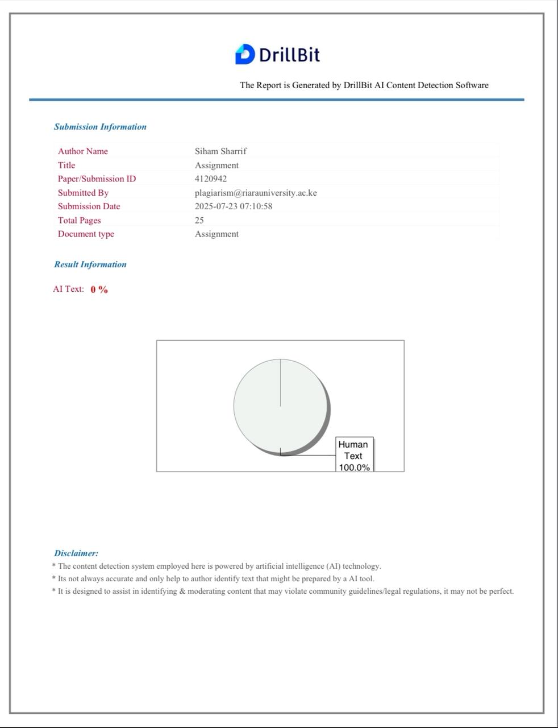

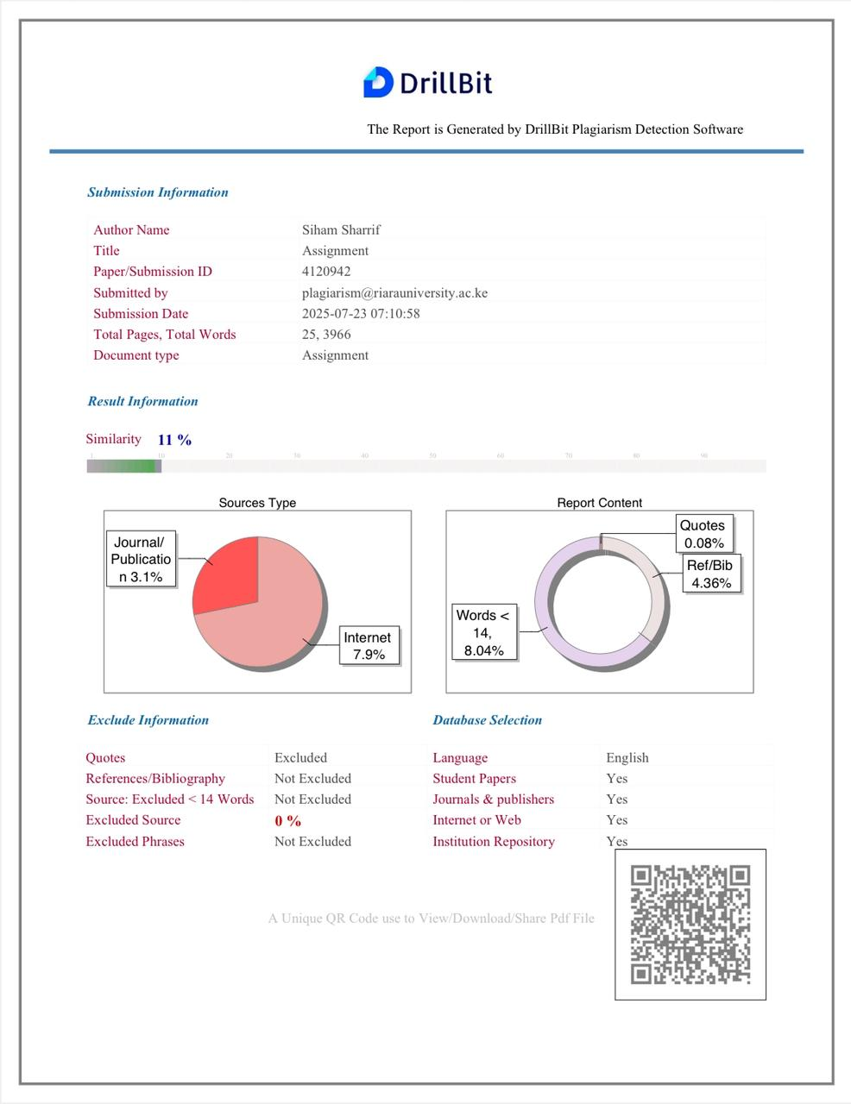
Appendix (3) Plagiarism Result

